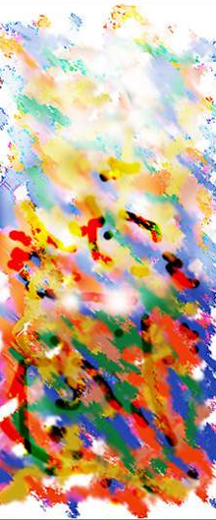
Artist: ______________
Name: ______________
Medium: ______________
Size: ______________
Price: ______________

